1、Igh主站配置向导
参考文档 源码工程路径见下方SourceCode地址
https://github.com/veysiadn/IgHEtherCATImplementation

SourceCode:
https://gitlab.com/etherlab.org/ethercat

EthercatLab api接口文档：
https://docs.etherlab.org/ethercat/1.6/doxygen/index.html

2、学习参考文档

https://blog.csdn.net/qq_50808730/article/details/139996092?spm=1001.2101.3001.6650.1&utm_medium=distribute.pc_relevant.none-task-blog-2%7Edefault%7EOPENSEARCH%7EPaidSort-1-139996092-blog-112647336.235%5Ev43%5Epc_blog_bottom_relevance_base2&depth_1-utm_sou

https://blog.csdn.net/qq_34539334/article/details/116152956

3、代码示例
源码中有示例可参考学习：
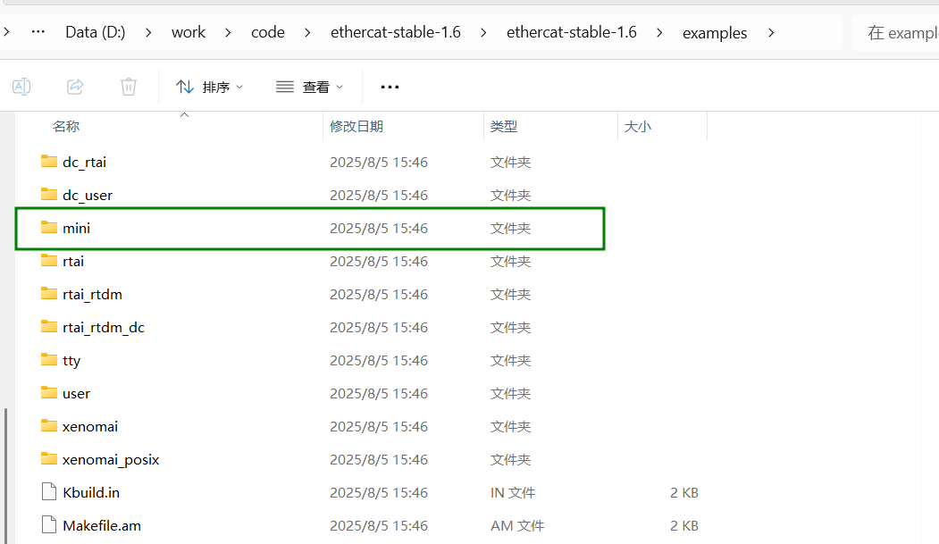

简单示例调用etherlab接口，csp模式。 ubuntu22.04

4、API简介
EtherLab C API 主要函数在头文件中定义：
路径（安装后）一般在：
/usr/include/ecrt.h
你可以直接查看：
less /usr/include/ecrt.h
常用函数分类：
1. 初始化主站接口

ec_master_t *ecrt_request_master(unsigned int master_index);int ecrt_release_master(ec_master_t *master);
2. 配置从站
ec_slave_config_t *ecrt_master_slave_config(ec_master_t *master,
uint16_t alias, uint16_t position,
uint32_t vendor_id, uint32_t product_code);
3. PDO 映射
int ecrt_slave_config_pdo_assign_add(ec_slave_config_t *sc, uint32_t assign);int ecrt_slave_config_pdo_mapping_add(ec_slave_config_t *sc, uint32_t index,
uint8_t subindex, uint8_t bit_length);
4. 同步管理器设置（SyncManager）
int ecrt_slave_config_sync_manager(ec_slave_config_t *sc, uint8_t sm_index,
ec_direction_t direction, uint32_t pdo_assign,
uint8_t watchdog_mode);
5. 周期任务相关
ecrt_master_receive(master);
ecrt_domain_process(domain);
ecrt_domain_queue(domain);
ecrt_master_send(master);
6. 获取和设置 PDO 数据
uint8_t *domain_pd = ecrt_domain_data(domain);uint8_t control_word = EC_READ_U8(&domain_pd[offset]);
EC_WRITE_U16(&domain_pd[offset], value);

